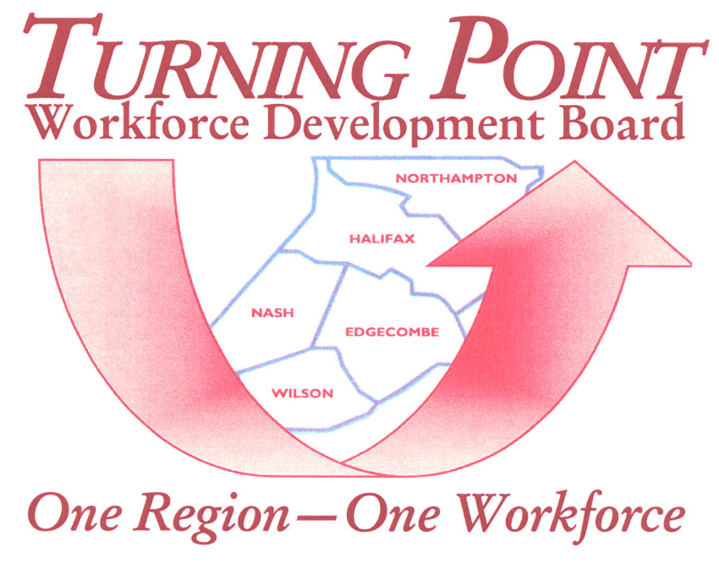
Looking for experienced workers?
The Local Area Workforce Development Board in partnership with NC Works is assisting QVC dislocated workers. Take advantage of this virtual event and sign up to gain new employees, interview and chat!
VIRTUAL HIRING EVENT
TUESDAY, JANUARY 18, 2022
10:00 AM – 2 PM

Click on the following link or paste into browser to register your company to interview experience workers: https://pvapi.premiervirtual.com/s/WzvV5W

