Turning Point
Workforce Development Region

Rapid Response Information Packet
For Dislocated Workers

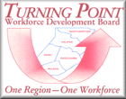
www.turningpointwdb.org

Serving the following Counties:
Northampton Halifax Nash Edgecombe Wilson

Virtual Rapid Response Packet Contents

Filing for Unemployment Insurance Due to “confirmed” issues affecting employment such as COVID or disasters (natural and non)

- 10 Things You Should Know About the UI System When Filing Your Claim

- NCWorks Career Centers of the Turning Point Workforce Region
  - Finding a Career Center
  - Career Center Services

- NCWorks Online (NCWorks.gov)
  - New User - Creating an Account
  - Existing User - Logging In
  - Forgotten ID or Password

- Workforce Transition and Community Assistance Resources on NCWorks.gov
  - Local Resources – NCWorks Career Centers
  - Health Insurance and Other Health-related Resources
  - Financial Resources
  - Resources for Families and Children
  - Temporary Assistance Programs
  - Legal Resources
  - Government Benefits Eligibility Resources
  - Caregiver Resources
  - Disability Resources
Note: NC Works Career Centers do not process unemployment application claims.
All unemployment applications and questions are received and updated via the Department of Employment Security. DES Customer the phone number is Call Center 888-737-0259 (www.des.gov) If your employer is filing on behalf of the team members, you will still be notified of the process for certifications and proper submittal of any documentation for UI; the following document shows a SAMPLE proper instruction for filings due to COVID as the reason for closure or layoff, However these steps are to be taken for other filing as well. Specifics to your Employer or the reasons for closing will be noted at the Unemployment Division office ahead of your filing if you are a dislocated worker. (jobloss at no fault of your own)
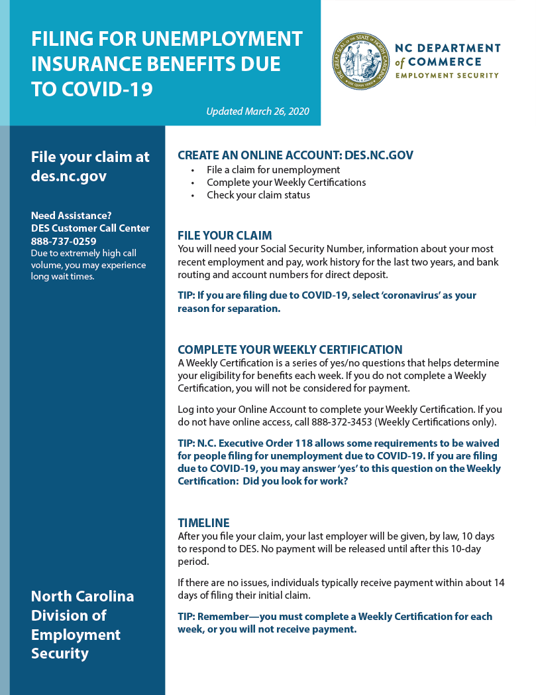
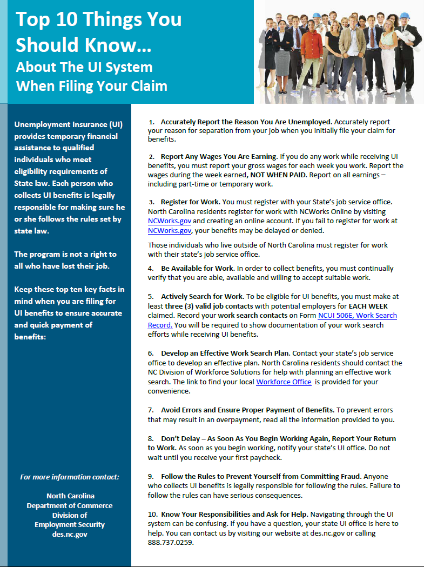
7. Avoid Errors and Ensure Proper Payment of Benefits. To prevent errors that may result in overpayment, read the information provided to you.
10. Know Your Responsibilities and Ask for Help. Navigating through the UI system can be confusing. If you have a question, your state UI office is here to help. You can contact us by visiting our website at des.nc.gov or calling 888.737.0259.
9. Follow the Rules to Prevent Yourself from Committing Fraud. Anyone who collects UI benefits is legally responsible for following the rules. Failure to follow the rules can have serious consequences.
8. Don’t Delay – As Soon As You Begin Working Again, Report Your Return to Work. As soon as you begin working, notify your state’s UI office. Do not wait until you receive your first paycheck.
6. Develop an Effective Work Search Plan. Contact your state’s job service office to develop an effective plan. North Carolina residents should contact the NC Division of Workforce Solutions for help with planning an effective work search. The link to find your local Workforce Office is provided for your convenience.
5. Actively Search for Work. To be eligible for UI benefits, you must make at least three (3) valid job contacts with potential employers for EACH WEEK claimed. Record your work search contacts on Form NCUI 506E, Work Search Record. You will be required to show documentation of your work search efforts while receiving UI benefits.
4. Be Available for Work. In order to collect benefits, you must continually verify that you are able, available and willing to accept suitable work.
3. Register for Work. You must register with your State’s job service office. North Carolina residents register for work with NCWorks Online by visiting NCWorks.gov and creating an online account. If you fail to register for work at NCWorks.gov, your benefits may be delayed or denied.

Those individuals who live outside of North Carolina must register for work with their state’s job service office.
2. Report Any Wages You Are Earning. If you do any work while receiving UI benefits, you must report your gross wages for each week you work. Report the wages during the week earned, NOT WHEN PAID. Report on All earnings – including part-time or temporary work.
1. Accurately Report the Reason You Are Unemployed.
Accurately report your reason for separation from your job when
You initially file your claim for benefits.
NCWorks Career Centers

NC Works Career Centers provide job search assistance, resume and interviewing assistance, Veteran’s services, and many other services.
*At this time due to the COVID-19 pandemic, all NCWorks Career Centers may be on altered schedules to the public but emails and voice messages will be addressed if Centers are closed or if hours are changed from normal 8:00 am to 5:00 pm times. If there are any changes, this will be made public.

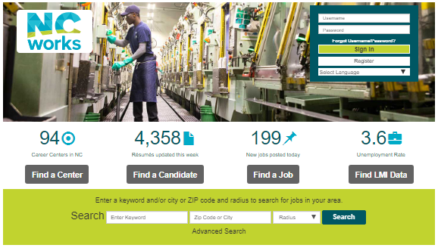
Find a local NCWorks Career Center at NCWorks.gov - “Find a Center”
WHERE ARE YOUR LOCAL CAREER CENTERS?

NC Works Career Center NC Works Career Center
793 Country Club Drive 302 Tarboro Street
Rocky Mount, NC 27804 Wilson NC 27893
(252) 977-3306 (252) 234-1129
ncworks.7600@nccommerce.com ncworks.9600@nccommerce.com

NC Works Career Center
126 Premier Drive
Roanoke Rapids, NC 27870
(252) 537-4188
ncworks.7400@nccommerce.com

NCWorks Career Center Services
What do Centers Provide ?
Career Services
Career Services are tailored specifically to an individual’s need(s) to help enhance their job search efforts. Some Career Services include but are not limited to:

- Registration for work through NCWorks.gov
- Career counseling, job search and job placement assistance
- Interviewing preparation
- Resume writing assistance
- Job search workshops
- Self-assessment or testing instruments to determine interests and abilities
- Development of an employment plan to identify goals
- Labor market information to include demand occupations, wages and required skills
- Information on filing a claim for Unemployment Insurance Benefits
- Financial aid information

Training Services
Individuals must have the skill prerequisites for the training selected and the training program selected must be linked to job opportunities in the local area. Training services include but are not limited to:

- Occupational skills training, including non-traditional training
- Workplace training with related instruction
- Skills up-grading and retraining
- Adult education and literacy activities in combination with training activities listed above
- On-the-Job training
- Employability skills training

NCWorks Online NCWorks.gov
WHAT IS NCWORKS.GOV USED FOR?
NCWorks Online can be used to perform job searches, find local employment events, locate online and local training resources and many other services.

New User – Creating a New Account (REGISTERING)
- From the home page of ncworks.gov (under Sign In), click Register
- Under Option 3 – Create a User Account, click Individual
- Follow the steps and fill in all required (*) fields. When the “What would you like to do next?” page appears, your account is created and you are signed in
Existing User – Logging In )
IF YOU ALREADY HAVE ACCOUNT
- From the home page of ncworks.gov, click Sign In
- Enter your name and password
- Click the Sign In button
Forgot Your Username or Password
- From the home page of ncworks.gov, click Forgot Username/Password
- Select your retrieval option
Workforce Transition and Community Assistance Resources
Other Helpful Services
Local and online services and service providers, most offer free or reduced cost services.
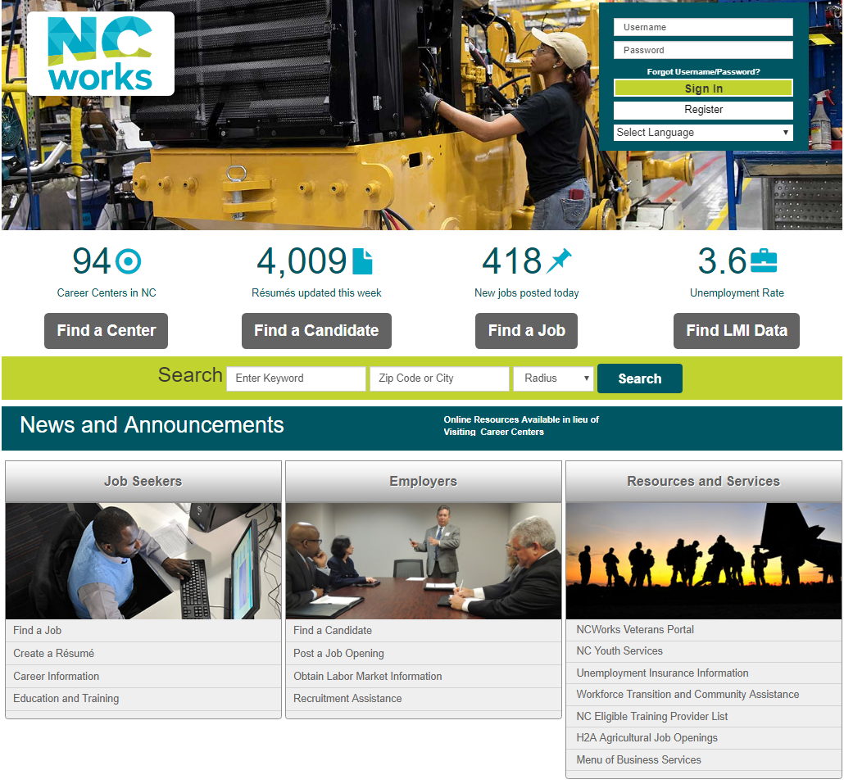

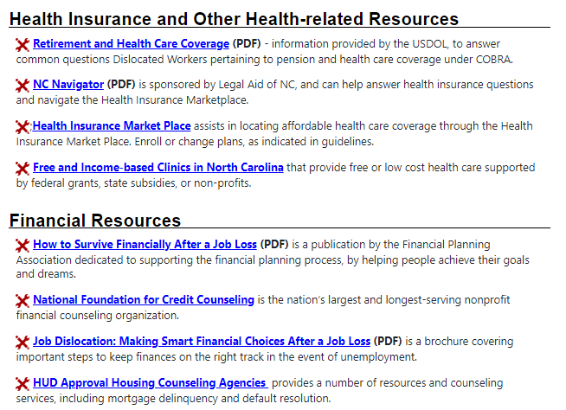
Resources on NCWorks.gov
Local Resources
Health Insurance
Health-related Resources
Financial Resources
Resources for Families and Children
Temporary Assistance Programs
Legal Resources
Government Benefits Eligibility
Caregiver Resources
Disability Resources

